**COMPUTER SCIENCE DEPARTMENT**

LAB: Database System

**Lab Task # 03**

**Last date of Submission: 11th October 2024**

# Submitted To: Mam Kashia Riaz

**Student Name: UBAID-BIN-WARIS**

# Reg. Number: 2212416

# 

**Question #01**

Consider a university database for the scheduling of classrooms for final exams.

This database could be modeled as the single entity set exam, with attributes course-name, section-number, room-number, and time.

Alternatively, one or more additional entity sets could be defined, along with relationship sets to replace some of the attributes of theexam entity set, as

* course with attributes name, department, and c-number
* section with attributes s-number and enrollment, and dependent as a weak entity set on course.
* room with attributes r-number, capacity, and building

**Solution**

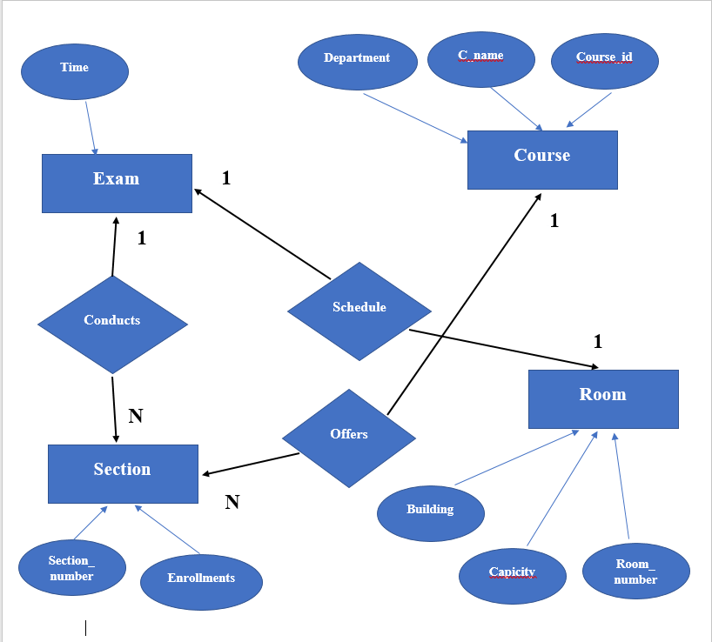

**Question #02**

Construct an ER Diagram for Company having following details :

Company organized into DEPARTMENT. Each department has unique name and a particular employee who manages the department. Start date for the manager is recorded. Department may have several locations.

* A department controls a number of PROJECT. Projects have a unique name, number and a single location.
* Company’s EMPLOYEE name, ssno, address, salary, sex and birth date are recorded. An employee is assigned to one department, but may work for several projects (not necessarily controlled by her dept). Number of hours/week an employee works on each project is recorded; The immediate supervisor for the employee.
* Employee’s DEPENDENT are tracked for health insurance purposes (dependent name, birthdate, relationship to employee).

**Solution**

